COMPUTER STUDIES WEEK 1

1. Principal uses of word processing software packages include:

I. preparing deft articles for publication;

II. preparing reports for top management;

III. preparing accounts;

IV. preparing organisation’s newsletter.

~

1. **I, II and IV only~**
2. I, III and IV only
3. II, III and IV only
4. I, II, III and IV
5. Editing features in a word processor does not include……..
6. Thesaurus
7. Copy and paste
8. Spelling
9. Animation
10. When one copies an item, it is kept in the ………………..
11. Memory
12. Clipboard
13. Hard disk
14. Monitor
15. Alignment of text can be done to the
16. Right
17. Left
18. a and b
19. None of the above
20. Spelling and grammar tool is used to ensure that a document is
21. Error free
22. Well organized
23. Properly formatted
24. Completely organized
25. A
26. D
27. B
28. C
29. A

COMPUTER SS 2 WEEK 2

1. One of the following are example of word processing package
2. WordPad
3. Microsoft Access
4. Microsoft Excel
5. CorelDraw
6. To make a text bold ,italized and centered the command is
7. Ctrl + B, Ctrl V, Ctrl + E
8. Ctrl + E, Ctrl I, Ctrl + BZ
9. Ctrl + J, Ctrl V, Ctrl + E
10. Ctrl + I, Ctrl V, Ctrl + E
11. To draw a table in Microsoft word, which of the following tab is clicked
12. HOME
13. VIEW
14. INSERT
15. DESIGN
16. Which tab helps you to format your page properties
17. INSERT
18. PAGE LAYOUT
19. DESIGN
20. VIEW
21. To password a document the following commands is used
22. File>Protect document>Encrypt Document>input Password>OK
23. File> Encrypt Document >Protect document> >input Password>OK
24. File>Protect document> input Password>Encrypt Document> OK
25. File>Protect document>Encrypt Document> OK >input Password>

Answers

1. A
2. B
3. C
4. B
5. A

COMPUTER STUDIES SS 2 WEEK 3

1. __________________ require system analysis and design
2. new systems
3. existing system
4. all of the above
5. none of the above
6. ___________ is the first stage in system development cycle
7. Design
8. Analysis
9. Implementation
10. Testing
11. In which stage is the requirement of the system actualized and used in the organization
12. Testing
13. Analysis
14. Implementation
15. Design
16. Which of the following is not a data gathering technique in system development life cycle?
17. Interviews
18. Observations
19. Photography
20. Questionnaires
21. The stage that involves debugging is called
    1. Design stage
    2. Implementation stage
    3. Testing stage
    4. Looking for error stage

Answers

* + - 1. C
      2. B
      3. C
      4. C
      5. C

COMPUTER STUDIES SS 2 WEEK 4

1. The following are activities in the analysis stage except
2. Collecting data about current system
3. Finding out problems with the current system
4. Establish the problem that the customer needs solving
5. Designing data entry
6. The following are validation checks except
7. Presence check
8. Range check
9. Data type check
10. Clock check
11. The following are stages of development except
12. Creating file structures to store data
13. Creating validation rule to make sure data entered is sensible
14. Creating a user interface to allow data to be entered into the system
15. Designing data entry screens
16. The following are type of test data
17. Normal data
18. Extreme data
19. Abnormal data
20. Lost data
21. The following data are used before the system is delivered to the customer except
22. Normal data
23. Extreme data
24. Abnormal data
25. Live data

Answers

1. D
2. D
3. D
4. D
5. D

COMPUTER STUDIES SS 2 WEEK 5

DECUMENTATION, EVALAUTION, IMPLEMENTATION

1. System development simply means
2. Designing a system
3. Building the system
4. System Design Life Cycle
5. Structure development Life Cycle
6. The stages in system development stage are except
7. Creating file structure
8. Creating validation checks
9. Designing validation rules
10. Creating input methods
11. Changing over to the new system can be done in the following way except
12. Direct changeover
13. Parallel running
14. Pilot running
15. Indirect changeover
16. One of the following is a type of documentation in system design and analysis
17. Technical documentation
18. Defined documentation
19. Paper documentation
20. Computerized documentation
21. System evaluation is carried out to determine if
22. The system is doing the job it was designed to do
23. The system is working well with minimum errors
24. Staff can use the system properly
25. I only
26. II and II only
27. I , II and III
28. II only

Answers

1. B
2. C
3. D
4. A
5. C

COMPUTER STUDIES SS 2 WEEK 8

1. The analysis phase of software development involves
2. Collecting the requirement about what the program will accomplish
3. Creating a detailed plan on how the program will accomplish the requirements
4. Writing the software with a program such as VB.NET
5. Both a and b
6. ______________ is the process of translating a task into a series of commands that computer will use to perform that task.
7. Project design
8. Installation
9. System analysis
10. Programming
11. Debugging is ___________
12. Creating program code
13. Finding and correcting errors in the program code
14. Identifying the task to be computerized
15. Creating the algorithm
16. Translating the algorithm into a programming language occurs at the ___________ step of the PDLC
17. Debugging
18. Coding
19. Testing and documentation
20. Algorithm development
21. Translating the problem statement into a series of sequential steps describing what the program must do is known as
22. Coding
23. Debugging
24. Creating the algorithm
25. Writing documentation

ANSWER

1. A
2. D
3. B
4. B
5. C

COMPUTER STUDIES SS 2 WEEK 9

1. Algorithm and flowchart help us to ___________
2. Know the memory capacity
3. Identify the base of the number system
4. Direct the output to a printer
5. Specify the problem completely and clearly
6. The __________ symbol is used in a flowchart to represent a step that gets information from the user
7. Input/Output
8. Process
9. Selection / Repetition
10. Start / stop
11. ___________________use standardized symbols to represent an algorithm
12. Flowcharts
13. Flow diagrams
14. IPO charts
15. Pseudocode
16. An algorithm is written in English like statements called ____
17. Algorithm Language
18. Assembly language
19. Programming language
20. Pseudocode
21. 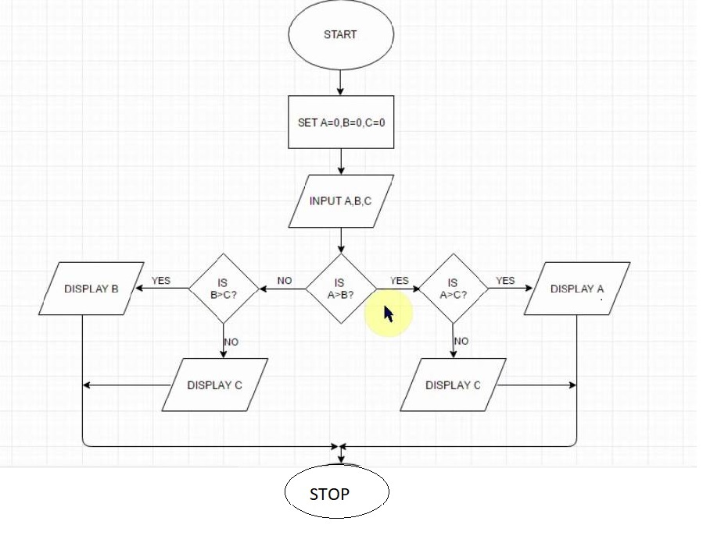

The problem represented by the flowchart above is

1. Finding the largest of 3 numbers
2. Finding the sum of 3 number
3. Finding the largest of 4 numbers
4. Subtracting two numbers